Contact and information:
Thomas Roth
RÖHM GmbH
Heinrich-Röhm-Str. 50
89567 Sontheim a.d. Brenz
Tel. +49 (0)7325 / 16 380
thomas.roth@roehm.biz
www.roehm.biz

Röhm wins ‘Best of Industry’ award
Great jubilation at Röhm: the clamping and gripping specialist based in Sontheim an der Brenz has just been awarded a prize by the renowned trade magazine MaschinenMarkt – for its smart 'iJaw' clamping jaw. A total of 180 innovative products were on the ballot, and Röhm’s innovation received the most votes in the clamping tool category. The jury is probably one of the toughest around, because users themselves were able to take part in the online voting. In total, there were 20,000 votes cast. The ‘Best of Industry’ Award has been paying tribute to the latest developments and advances in various categories since 2016 and thus selects the best of the best every year.

‘This award is a great confirmation for our entire team. With the iJaw, we offer users a whole range of advantages in the metalworking production process and make a significant contribution to process optimization. I am very pleased that our innovation is the clear number one in the opinion of the experts,’ says Thomas Roth, Head of Business Development at Röhm GmbH.

What makes the iJaw so innovative?
The iJaw from Röhm is the first clamping jaw ever to be equipped with sensor technology and wireless data transmission. This allows the clamping and machining forces to be measured in real time during the machining. Data transmission to a gateway takes place via the industry standard IO-Link Wireless.

The real-time measurement of clamping and machining forces during the machining process brings the user a whole range of advantages – such as faster set-up, predictive maintenance of the clamping tools and cycle time reduction. The variety of use scenarios leads in the last resort to higher productivity, lower part costs, documentation of measurement data and higher safety standards in machining. This is pure process optimization and a real milestone in the digitalization of manufacturing.

More information on the technology behind the iJaw may be found here.
Press article:
https://www.roehm.biz/aktuell/news/einzelansicht/amb-premiere-fuer-die-smarte-spannbacke-ijaw-von-roehm/
YouTube Video:
https://www.youtube.com/watch?v=I9dbyQzXiaM&t=1s
Website:
https://roehm-smarter-clamping.com/

Graphics:
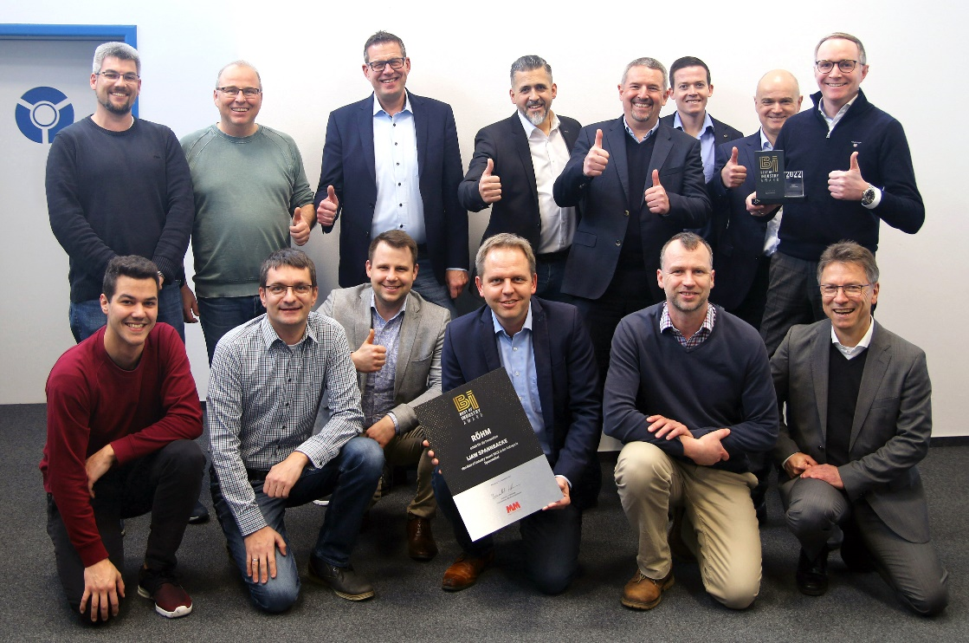
Fig. 1: The iJaw team is delighted to receive the ‘Best of Industry’ award.

