Contact and information:
RÖHM GmbH
Thomas Roth
Heinrich-Röhm-Str. 50
89567 Sontheim a.d. Brenz
Tel. +49 (0)7325 / 16 380
thomas.roth@roehm.biz
www.roehm.biz

AMB premiere for the smart chuck jaw “iJaw” from Röhm

From now on, clamping is smart: Röhm, the clamping and gripping specialist based in Sontheim an der Brenz (Baden-Württemberg, Germany), is presenting its world premiere iJaw at AMB in Stuttgart. It is the first chuck jaw ever to be equipped with sensor technology and wireless data transmission. It allows the clamping force to be measured in real-time directly during machining. Data is transmitted to a gateway via the industry standard IO-Link Wireless.

Great News: OEMs (the original equipment manufacturers) can now integrate a smart chuck jaw into their machines and PLC controllers displaying clamping forces on their HMI (human machine interface) displays.iJaw development partner DMG Mori is so enthusiastic about the functionalities that its machine tools can now be configured with iJaw. Other partners, such as WFL Millturn, Mazak, and Emco will also be presenting machines with iJaw applications at the AMB in Stuttgart.
But existing inventory can also be updated to smarter clamping with a retrofit On-Premises” interface and display independent of the machine’s electronics. This After Market iJaw upgrade is also available for most non-Röhm quick change jaw chucks.

Revolution in metalworking

"With iJaw, we are effectively revolutionizing the manufacturing process in metalworking. This is because real-time measurement of the clamping force during the machining process provides the user with a whole range of benefits. This starts with higher machine availability because setup times can be reduced and machining processes accelerated. This reduces part costs on the one hand, while part quality increases on the other. This is pure process optimization and a real milestone in the digitalization of manufacturing. Overall, sensor-controlled workpiece machining is, of course, much safer than conventional manual clamping by feel," says Gerhard Glanz, CEO of Röhm GmbH.

Safety even with thin-walled workpieces

Gone are the days when the clamping force was set higher than necessary in order to play it safe. "Especially with thin-walled components or sensitive surfaces, this is known to be counterproductive because too much clamping force here quickly leads to deformation or even crushing of the workpiece. You can significantly reduce rejects with precise sensor-controlled machining," says Glanz.

This is how the iJaw works: The forces applied by the jaw are detected by an integrated sensor, and the data is transmitted and processed accordingly. The iJaw measures not only the actually applied forces of the internal and external clamping but also its own temperature. The charging status of the battery is also always visible. If data from the pressure display is available, the iJaw can also be used to monitor the condition and efficiency of the power chuck. The iJaw measures in real-time during machining. For this purpose, it has a suitably robust hardened steel and waterproof (IP 68) design. The transmitting antenna has a cover made of high-temperature resistant plastic to protect against glowing chips.

Gateway as a data hub

The iJaw transmits the measured data wirelessly to a gateway via the robust IO-Link Wireless protocol with a high sampling rate of 100 Hz.
The gateway consists of an industrial PC for data processing and interfaces and the IO-Link Wireless Master. The gateway communicates with the iJaw via IO-Link Wireless technology. The data is transferred either via Ethernet to a processor via the integrated LAN interface and then accessible via WiFi for On-Premises displays. Of course, the data can also be processed directly in the machine tool’s PLC. For this purpose, the gateway is connected to the machine via the integrated Profinet interface. The machine controller can process the data in real-time and display it on the machine panel. The universal iJaw Gateway from Röhm uses only standard protocols and interfaces. Their specification is freely accessible. Further sensors – your own or also from third-party suppliers – can be integrated with the universal gateway without additional hardware.

Retrofitting made easy

It will soon be possible to very easily retrofit machine tools iJaw. In addition to installing the chuck jaws with integrated sensors, users only need the gateway with an adjacent industrial processor, and a display for accessing the data. This can be an instaled PC or a mobile tablet. The system is then controlled by the iJaw Mobile web app that establishes the connection between the iJaw and the gateway. "Through iJaw Mobile, users can then create jobs, manage their jaws, and, of course, receive alerts, for example, if the minimum clamping force is not reached," explains Glanz.

Soon to be available in the cloud: The digital fingerprint of machining

The option of utilizing cloud services with the iJaw system will also soon be available. This will enable additional functions such as process or productivity analyses and the documentation of large quantities of measurement data. With the iJaw Mobile app, users can thus access the data from anywhere and evaluate processing parameters or have warning messages displayed. "Especially in the production of components with mandatory documentation, such as aerospace manufacturing, this is a very attractive feature. The iJaw archives the digital fingerprint of the machining process, so to speak," says Glanz.

Flexible in use

The iJaw can be mounted and used on all lathe chucks with a suitable (standard) jaw interface like any other chuck jaw. For the market launch, the iJaw is available as a single-stage jaw, two-stage jaw, and block jaw for lathe chucks with straight gearing in the sizes, 260, 315, and 400 as well as a special jaw for independent chucks. One such chuck from Röhm is the Duro-A RC power chuck with the quick jaw change feature. Various interchangeable hard and soft clamping inserts are locked onto the jaws with screws to adapt the jaws to different workpiece geometries.

About Röhm GmbH:
Röhm GmbH, with its headquarters in Sontheim an der Brenz (Baden-Württemberg) and production sites in Dillingen (Bavaria) and St. Georgen (Black Forest), specializes in the development, design, and manufacture of high-precision, robust and durable clamping and gripping devices. The products are "Made in Germany." Röhm's clamping and gripping devices are used worldwide by almost all renowned manufacturers in the automotive industry, railroad technology, watches, medical technology, power engineering as well as in woodworking. Röhm has its own subsidiaries in France, Italy, Switzerland, Spain, Poland, USA, China, and Mexico. Founded in 1909, the company quickly became known worldwide for its drill chucks. To this day, Röhm develops and manufactures drill chucks at the Sontheim location that are used worldwide by almost all manufacturers on stationary as well as hand-operated electric tools for screwing and drilling.

Photos:
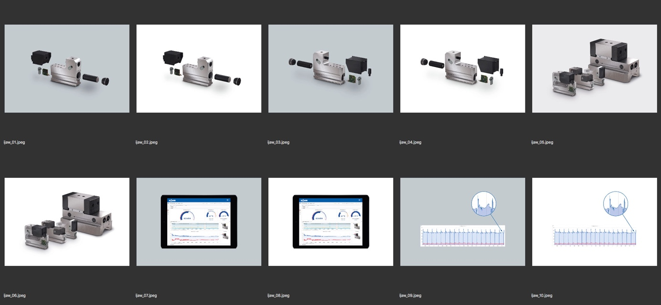

Photo captions:
ijaw_01.jpeg bis ijaw_04.jpeg
Structure of the sensorized clamping jaw iJaw from Röhm. Photo: Röhm

ijaw_05.jpeg und ijaw_06.jpeg
Available geometries of the iJaw. Photo: Röhm

ijaw_07.jpeg und ijaw_08.jpeg
With the "iJaw Mobile" app, the iJaw is controlled and clamping force data is visible in real time. Photo: Röhm

ijaw_09.jpeg und ijaw_10.jpeg
Clamping force curve of a component in the series process - The deviation at the end indicates irregularities. Photo: Röhm

Worddownload und Bildgalerie:
https://drive.google.com/drive/folders/1JlQBkCjOYit6ZGcqNZJlcsMeNVLKyRJh

