Contact and information:
RÖHM GmbH
Thomas Roth
Heinrich-Röhm-Str. 50
89567 Sontheim a.d. Brenz
Tel. +49 (0)7325 / 16 380
thomas.roth@roehm.biz
www.roehm.biz

F-Senso 2: The new all-rounder from Röhm for clamping force measurement

From now on, only one clamping force measuring device is needed in the workshop, the laboratory, and production: the new F-Senso 2 from Röhm. The clamping and gripping specialist, based in Sontheim an der Brenz (Baden-Württemberg, Germany), is presenting its new modular system at the AMB in Stuttgart and the IMTS in Chicago. It replaces both the previous F-Senso chuck and the spindle clamping force measuring devices.

The basis of the new F-Senso 2 is the Senso module which contains all the electronic components for data processing and wireless data transmission. Depending on the clamping device, different measuring heads are available that are simply screwed onto the Senso module as required. For HSK clamping sets, these are the HSK modules that are available in sizes 40, 50, 63, and 100 and cover the axial clamping forces from 0 to 90 kN (HSK 100). Chuck modules are available in sizes 32mm and 65mm for measuring the clamping force in vices as well as in manual or power lathe chucks (2- and 3-jaw chucks). The new F-Senso 2 from Röhm can be used stationary or under rotation.

A device for multiple applications

"With the F-Senso 2, we now have a true all-rounder in our product range that can measure both the clamping force of clamping devices and the pull-in force of tool spindles, as there are a range of measuring heads for a wide variety of measuring tasks," says Product Manager Fabian Baur.

Class for workshop and production managers: Röhm's F-Senso 2 comes as a complete package, i.e. including a tablet PC and corresponding software for visualization and archiving. "In addition, you can use the software to store service and inspection intervals for clamping devices on various machines and thus optimize the maintenance and inspection processes in the company. This is a valuable feature, particularly with regard to QM systems such as DIN EN 1550," says Baur. As is widely known, the standards for the safety of machine tools requires static clamping force measurements to be carried out and documented at regular intervals.

Simply clamp and go

This is how the F-Senso 2 works: After screwing the Senso module to the matching measuring head, the F-Senso 2 is paired with the tablet PC and then simply inserted into the clamping device to be measured. Then clamping takes place. The applied clamping force automatically activates the F-Senso 2, which wirelessly transmits the measured data to the tablet PC. To enable the chuck module to measure accurately, the appropriate measuring inserts are simply screwed into the measuring head.

However, the F-Senso 2 from Röhm not only measures the clamping force but also the speed and the centrifugal force attributes. A magnet included in the delivery scope serves as the speed sensor. It is simply positioned in the immediate proximity of the back of the Senso module.

The F-Senso 2 uses Bluetooth protocol for wireless data transmission, which gives the user an additional option. “If desired, the data can also be transmitted to an industrial PC with a bluetooth interface near the respective machine tool," explains Fabian Baur.

Röhm supplies its new F-Senso 2 measuring system in a handy complete set that fits into a hard case for storage and protection.

About Röhm GmbH:
Röhm GmbH, with its headquarters in Sontheim an der Brenz (Baden-Württemberg) and production sites in Dillingen (Bavaria) and St. Georgen (Black Forest), specializes in the development, design and manufacture of high-precision, robust and durable clamping and gripping devices. The products are "Made in Germany." Röhm's clamping and gripping devices are used worldwide by almost all renowned manufacturers in the automotive industry, railroad technology, watches, medical technology, power engineering as well as in woodworking. Röhm has its own subsidiaries in France, Italy, Switzerland, Spain, Poland, USA, China, and Mexico. Founded in 1909, the company quickly became known worldwide for its drill chucks. To this day, Röhm develops and manufactures drill chucks at the Sontheim location that are used worldwide by almost all manufacturers on stationary as well as hand-operated electric tools for screwing and drilling.

Artwork:
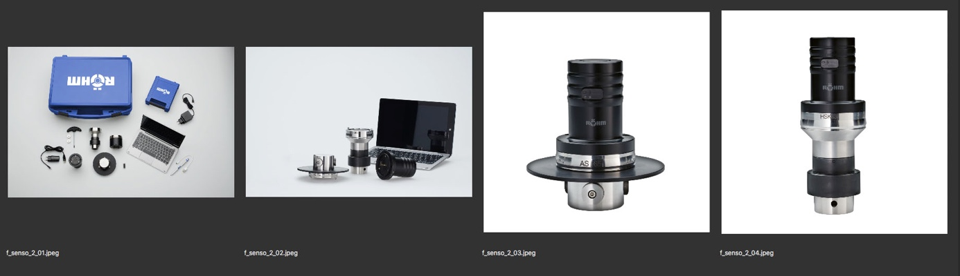

Captions:

f_senso_2_01.jpeg
Scope of delivery of the F-Senso 2 in a handy case. Photo: Röhm

f_senso_2_02.jpeg
The Senso measuring device with the Chuck and HSK modules and the PC for visualizing the clamping force data. Photo: Röhm

f_senso_2_03.jpeg
The F-Senso-2-Module Chuck. Photo: Röhm

f_senso_2_04.jpeg
The F-Senso-2-Module HSK. Photo: Röhm

Word download and picture gallery:

https://drive.google.com/drive/folders/17mlHSvEsP-vjcgnTReRxuPvko_6OwRvP

